1. Increase in sales: Without networking, the company will not know if the vending machines products are running of stock unless they do onsite monitoring which is not practical as vending machines are designed to sell products without human to human interaction. By networking the vending machines, the chances of products running out of stock will decrease substantially as the stock level is being transmitted to the server and monitored remotely. In this way, the company will know which products are running low on stock before consumers report to them. Thus, they will be able to restock the products before it runs out. Whenever products run out stock, consumers tend not to wait for the products to be restocked and results in sales decrease. By restocking before the products running out of stock, more consumers will be purchasing from the vending machines and sales will increase.
Maintenance and support: Without networking, the company will not know if vending machines are malfunctioning until a consumer reports the fault to them and by the time the machines get fixed, it is already too late as more sales are lost due to longer downtime. By networking the vending machines, it triggers alerts and reports are sent to the data centre whenever parts of the machines malfunction. Thus, the company will be able alerted much faster and send a team to fix the vending machines. By getting malfunctioned vending machines fixed faster, the downtime decreases and there will be more sales as well.

2.
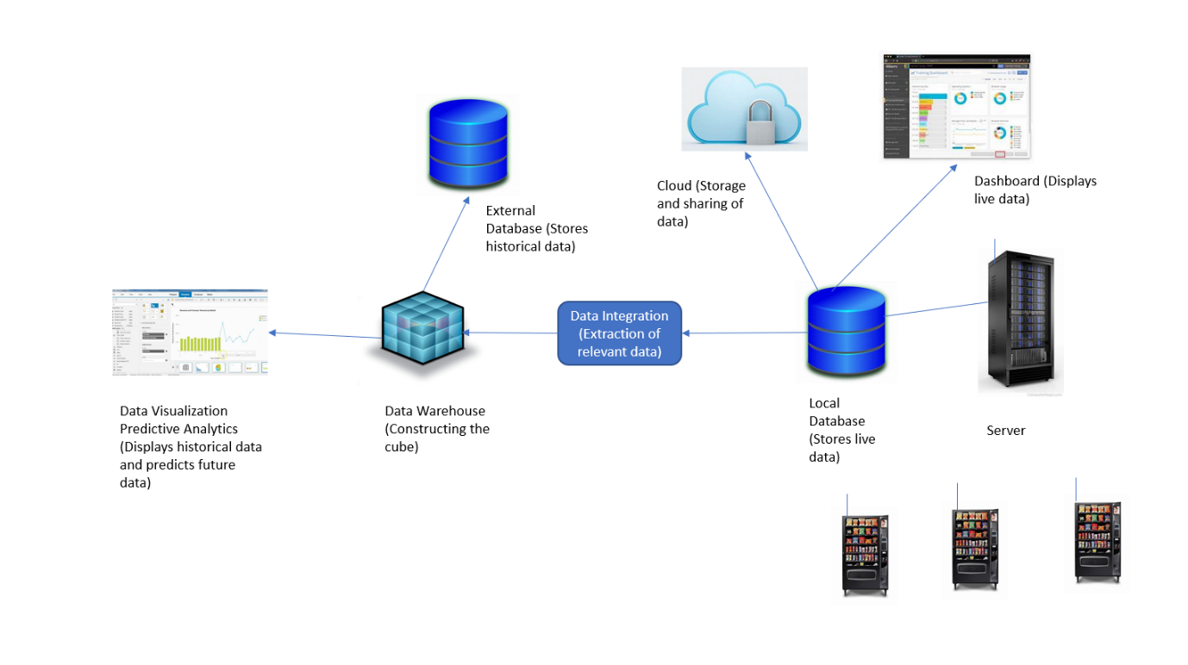

3. Bestselling product: Stocking equal amount of each product in vending machines isn’t always the best idea as the unsold products can expire before it gets sold and have to be thrown away, resulting in losses.
Example: One vending machine is stocked with 100 cans of Coca Cola, Sprite and Red Bull each. After a week, 88 cans of Sprite, 62 cans of Coca Cola and 28 cans of Red Bull are sold. In this situation, the company should stock around 140 cans of Sprite, 120 cans of Coca Cola and 40 cans of Red Bull in order to reduce the amount of expired unsold products.
Thus, by sending information on the amount of each product sold to the server, the company is able to make better decisions on how much to stock each product in each vending machine.
Stock level of products: By sending information on the stock level of products, the company will know which products are running low on stock. Thus, they will be able to restock the products before it runs out which can result in loss of sales and consumers.
Report of the vending machine: Whenever there are signs that the vending machines are breaking down (such as products taking longer than usual to dispense), the vending machines should send reports to the server. Thus, the vending machines can be scheduled for maintenance to reduce chances of breaking down. (Downtime) By reducing the downtime, more products will be sold and thus more revenue.

4. The most appropriate wireless technology would be ZigBee.
Explanation: For smart objects like networked vending machines, wireless communication technologies should consume low power, have low data rates and cover a wide range.
Low data rates: Wi-Fi and Bluetooth have higher data rates but ZigBee’s data rate is sufficient as the data generated from vending machines do not consume large amount of data
Low power consumption: The power should last as long as possible. (For months and years) Wi-Fi power consumption is too high to be used a wireless technology for vending machines as the battery needs to be recharged every few days which is not practical for the vending machines. Bluetooth and Zigbee have much lower power consumption than Wi-Fi.
Covers a wide range: The vending machines are positioned far apart from one another and the data centre. Bluetooth transmission distance is about 10m which is too short for the vending machines. Wi-Fi and Zigbee have much longer transmission distances of about 100m and 75m respectively which are sufficient and can be extended using routers.
Since Zigbee meets all three criteria, it will be the most appropriate wireless technology.

